Benefit for Emily
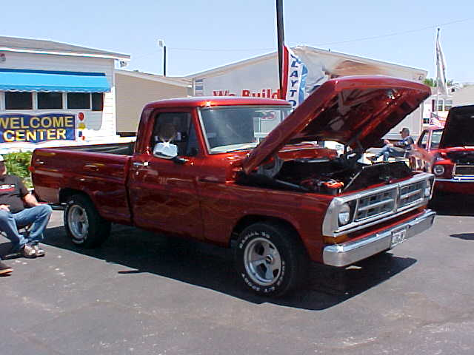
Come join the fun!
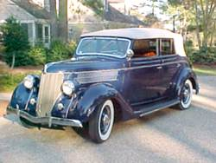
Please see her web page for more information.
http://getemilywalking.blogspot.com

Car Show

Sept. 16th. 2007- 2:00 PM to 6:00 PM

Rain date: Sept. 23rd 2007



5930 Overton Ridge Blvd.
Fort Worth, TX 76133

(817) 292-0078

$15.00 early Registration fee

$20.00 day of show,

Registration closes at 4:00 p.m.

Lot’s of fun for the whole family!

Live DJ – Doo Wopp Doug

Oldies Music – Original Vinyl

Cheryl Wright 817-270-1007 - cheryl0614@gmail.com

Silent Auction! Concession Stand! Door Prizes!
50/50 POT!
“First and Second place awards in each class”
17 Classes: T-Bucket & Roadsters, Pre 50’s, 50’s cars, 60’s cars, 70’s cars, 80’s & up cars, Motorcycles, Under Construction, Pre 60’s trucks, 60’s trucks, 70’s trucks, 80’s & up
Trucks, Young gun’s, Imports, Special Interest, & Stereo class. There will be one award for Best of show, Car, Truck, Motorcycle, Sponsors choice & Emily’s choice.

Motorcycles & Under Construction Welcome!

